**INTRODUCTION**

The Sustainable Forestry Initiative® (SFI) [2022 Standards](https://forests.org/sfi-2022-standards/) include requirements that promote and conserve Forests with Exceptional Conservation Value (FECV), which includes critically imperiled (G1) and imperiled (G2) species. This fact sheet summarizes the analysis of FECV habitat within this ecoregion and provides habitat management recommendations that would benefit species potentially found here.

**HABITAT TYPES**

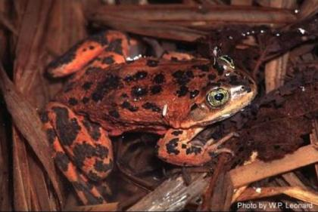

**Oregon Spotted Frog**

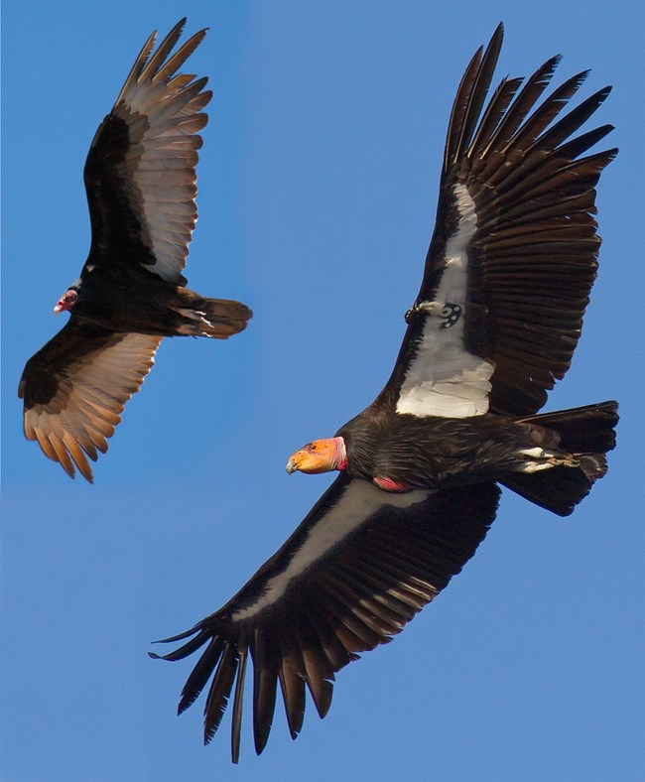

**California Condor**

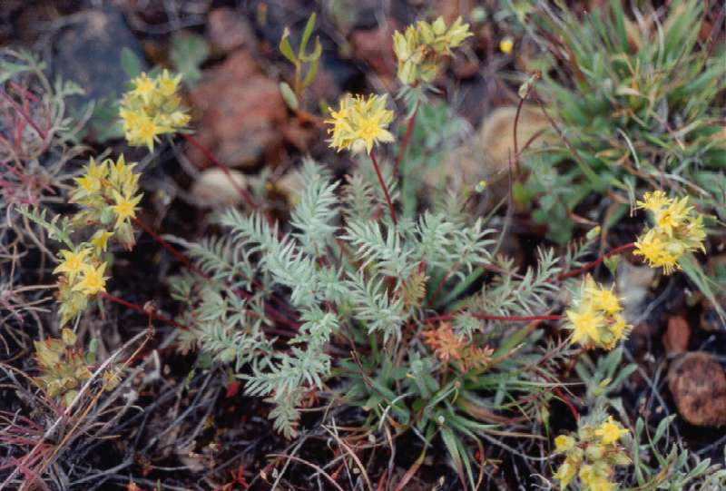

**Weber Ivesia**

* Bare Rock/Talus
* Cliff
* Riparian/Streams
* Shrubland/Chaparral

**BARE ROCK/TALUS MANAGEMENT**

* Protect known locations
* Buffer bare rock and talus areas

**RIPARIAN/STREAMS MANAGEMENT**

* Protect known locations
* Maintain well vegetated riparian buffers
* Plant a diversity of both hardwood and conifer trees
* Retain large diameter trees near streams, rivers and wetlands
* Buffer wetlands, springs, and headwater areas

**SHRUBLAND/CHAPARRAL MANAGEMENT**

* Protect known locations
* Buffer shrubland and chaparral areas

|  |  |  |  |
| --- | --- | --- | --- |
| **SCIENTIFIC NAME** | **COMMON NAME** | **HABITAT** | **STATUS** |
| *Tortula californica* | California Screw Moss | Bare Rock/Talus | G2 |
| *Gymnogyps californianus* | California Condor | Mixed Conifer Forest | G1 |
| *Rana pretiosa* | [Oregon Spotted Frog](https://explorer.natureserve.org/Taxon/ELEMENT_GLOBAL.2.101451) | Riparian/Streams | G2 |
| *Pyrgulopsis eremica* | [Smoke Creek Pyrg](https://explorer.natureserve.org/Taxon/ELEMENT_GLOBAL.2.150751) | Riparian/Streams | G2 |
| *Juga acutifilosa* | [Topaz Juga](https://explorer.natureserve.org/Taxon/ELEMENT_GLOBAL.2.150751) | Riparian/Streams | G2 |
| *Ivesia webberi* | [Webber Ivesia](https://explorer.natureserve.org/Taxon/ELEMENT_GLOBAL.2.150751) | Shrubland/Chaparral | G2 |

*\*Species links provided when available*

